Team Kereru 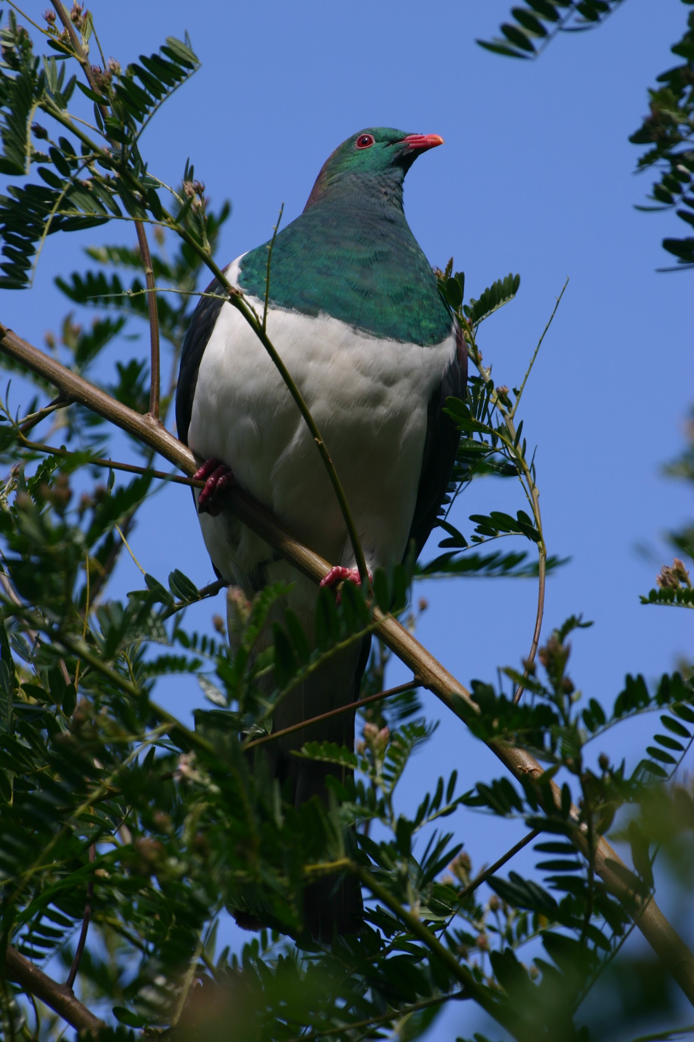

NEWSLETTER TERM 1 2016

2016 promises to be an exciting year. We begin with thinking and learning about class culture and setting up routines to be effective learners and collaborators. In PE and health we will take part in some awesome team building activities to prepare us for camp., moving to small ball skills. Programmes in maths and literacy will begin and the students will be grouped with like minds to work on their next learning goal. In visual art we will be exploring each child’s identity and culture. Homework will begin in Week 3. In 2016 we are implementing an exciting maths programme called Maths Buddy. This combined with our use of Google classroom and a reading log will help you to continue learning outside the classroom and equip you with universal skills as a learner. In Te Reo this year we will examine the principles of Tikanga. We will be looking at these Tikanga in light of the Rototuna Learner and the similarities and differences between these cultural practices and those of all the cultures of students within the team. This will be a rich learning experience which will help us get to know each other better. For topic we begin by learning about our families and also building resilience through the Kia Kaha programme. An important focus on cyber safety will also be included.

TEAM MEMBERS.
We have a team of 5 teachers this year.
Jane Macqueen Team Leader Room 23 Year 6 Tawa Hub
Jennifer Adams Room 22 Year 6 Tawa Hub
Tracey Moore Room 24 Year 6 Tawa Hub
Jaspreet Singh Room 21 Year 6 Tawa Hub
Melanie Johnson Room 17 Year 5/6 Rimu Hub
Feel free to visit these classrooms and check out the amazing learning environment. Please ensure you contact your child’s classroom teacher with any queries first. If you have further concerns please contact the Team Leader and then a member of the Senior Leadership Team.

CAMP
This term we will be attending Epworth camp. You will receive a number of notices over the coming weeks. It is important that you read these and return them as soon as possible. If you are able to be a camp parent you will receive a notice to express this interest. The camp payment is required in full before your child attends camp. Please make this payment at the office. If you are paying via direct credit please ensure you have made the payment in full. We must stress the importance of paying in full for your child. Numbers are very exact and we budget accordingly. These funds mean we can make the camp varied and filled with exciting activities.

IMPORTANT DATES.
Meet the Teacher: TBC
Waitangi Day: Observed February 8th
Swimming Sports: March 1st 2016
Camp March: 14th-17th March 2016
School Celebration: Begins Friday 12th February and continues each fortnight.

TIMES
Students should not arrive at school before 8am. When arriving at school wait in the covered courts until the bell at 8.30am. School begins at 9am with reflection at 2.50pm. We invite family to join us at Reflection time to share in our day of learning. School concludes at 3pm.
COMMUNICATION
In Team Kereru this year we will continue to communicate to you via a range of methods. These include the school newsletter, class letters, Facebook, EDUCA, emails, phone calls and texts. We also strive to communicate via Google docs and Google forms on a more frequent basis. This reduces the need for paper notices and delivers the message more directly. Your child will gain more experience with the Google tools this year in Google classroom. This tool will allow them to collaborate with classmates and also continue learning when they get home. Using Gmail at home and Chrome can assist with this process.

IMPORTANT DETAILS
- Hats required in Term 1. Wide brim and NO caps.
- Each classroom has sunscreen for you to apply if needed or you may supply your own.
- Lunch orders can be ordered before 8.30am www.lunchorders.co.nz
- Newsletters are sent home every Wednesday.
- Please bring an old shirt to wear for art activities.
- Keep an eye out for sports emails asking you to sign up for the exciting range of sporting options at Rototuna.
- Make sure all your stationery is labeled. Covering your books does help them to last longer.
- Please pack a drink bottle each day.
- Make sure your shoulders are covered. This means no singlets for boys or girls.
- All money goes to the office.
- If your details such as address and phone number change please notify the office.

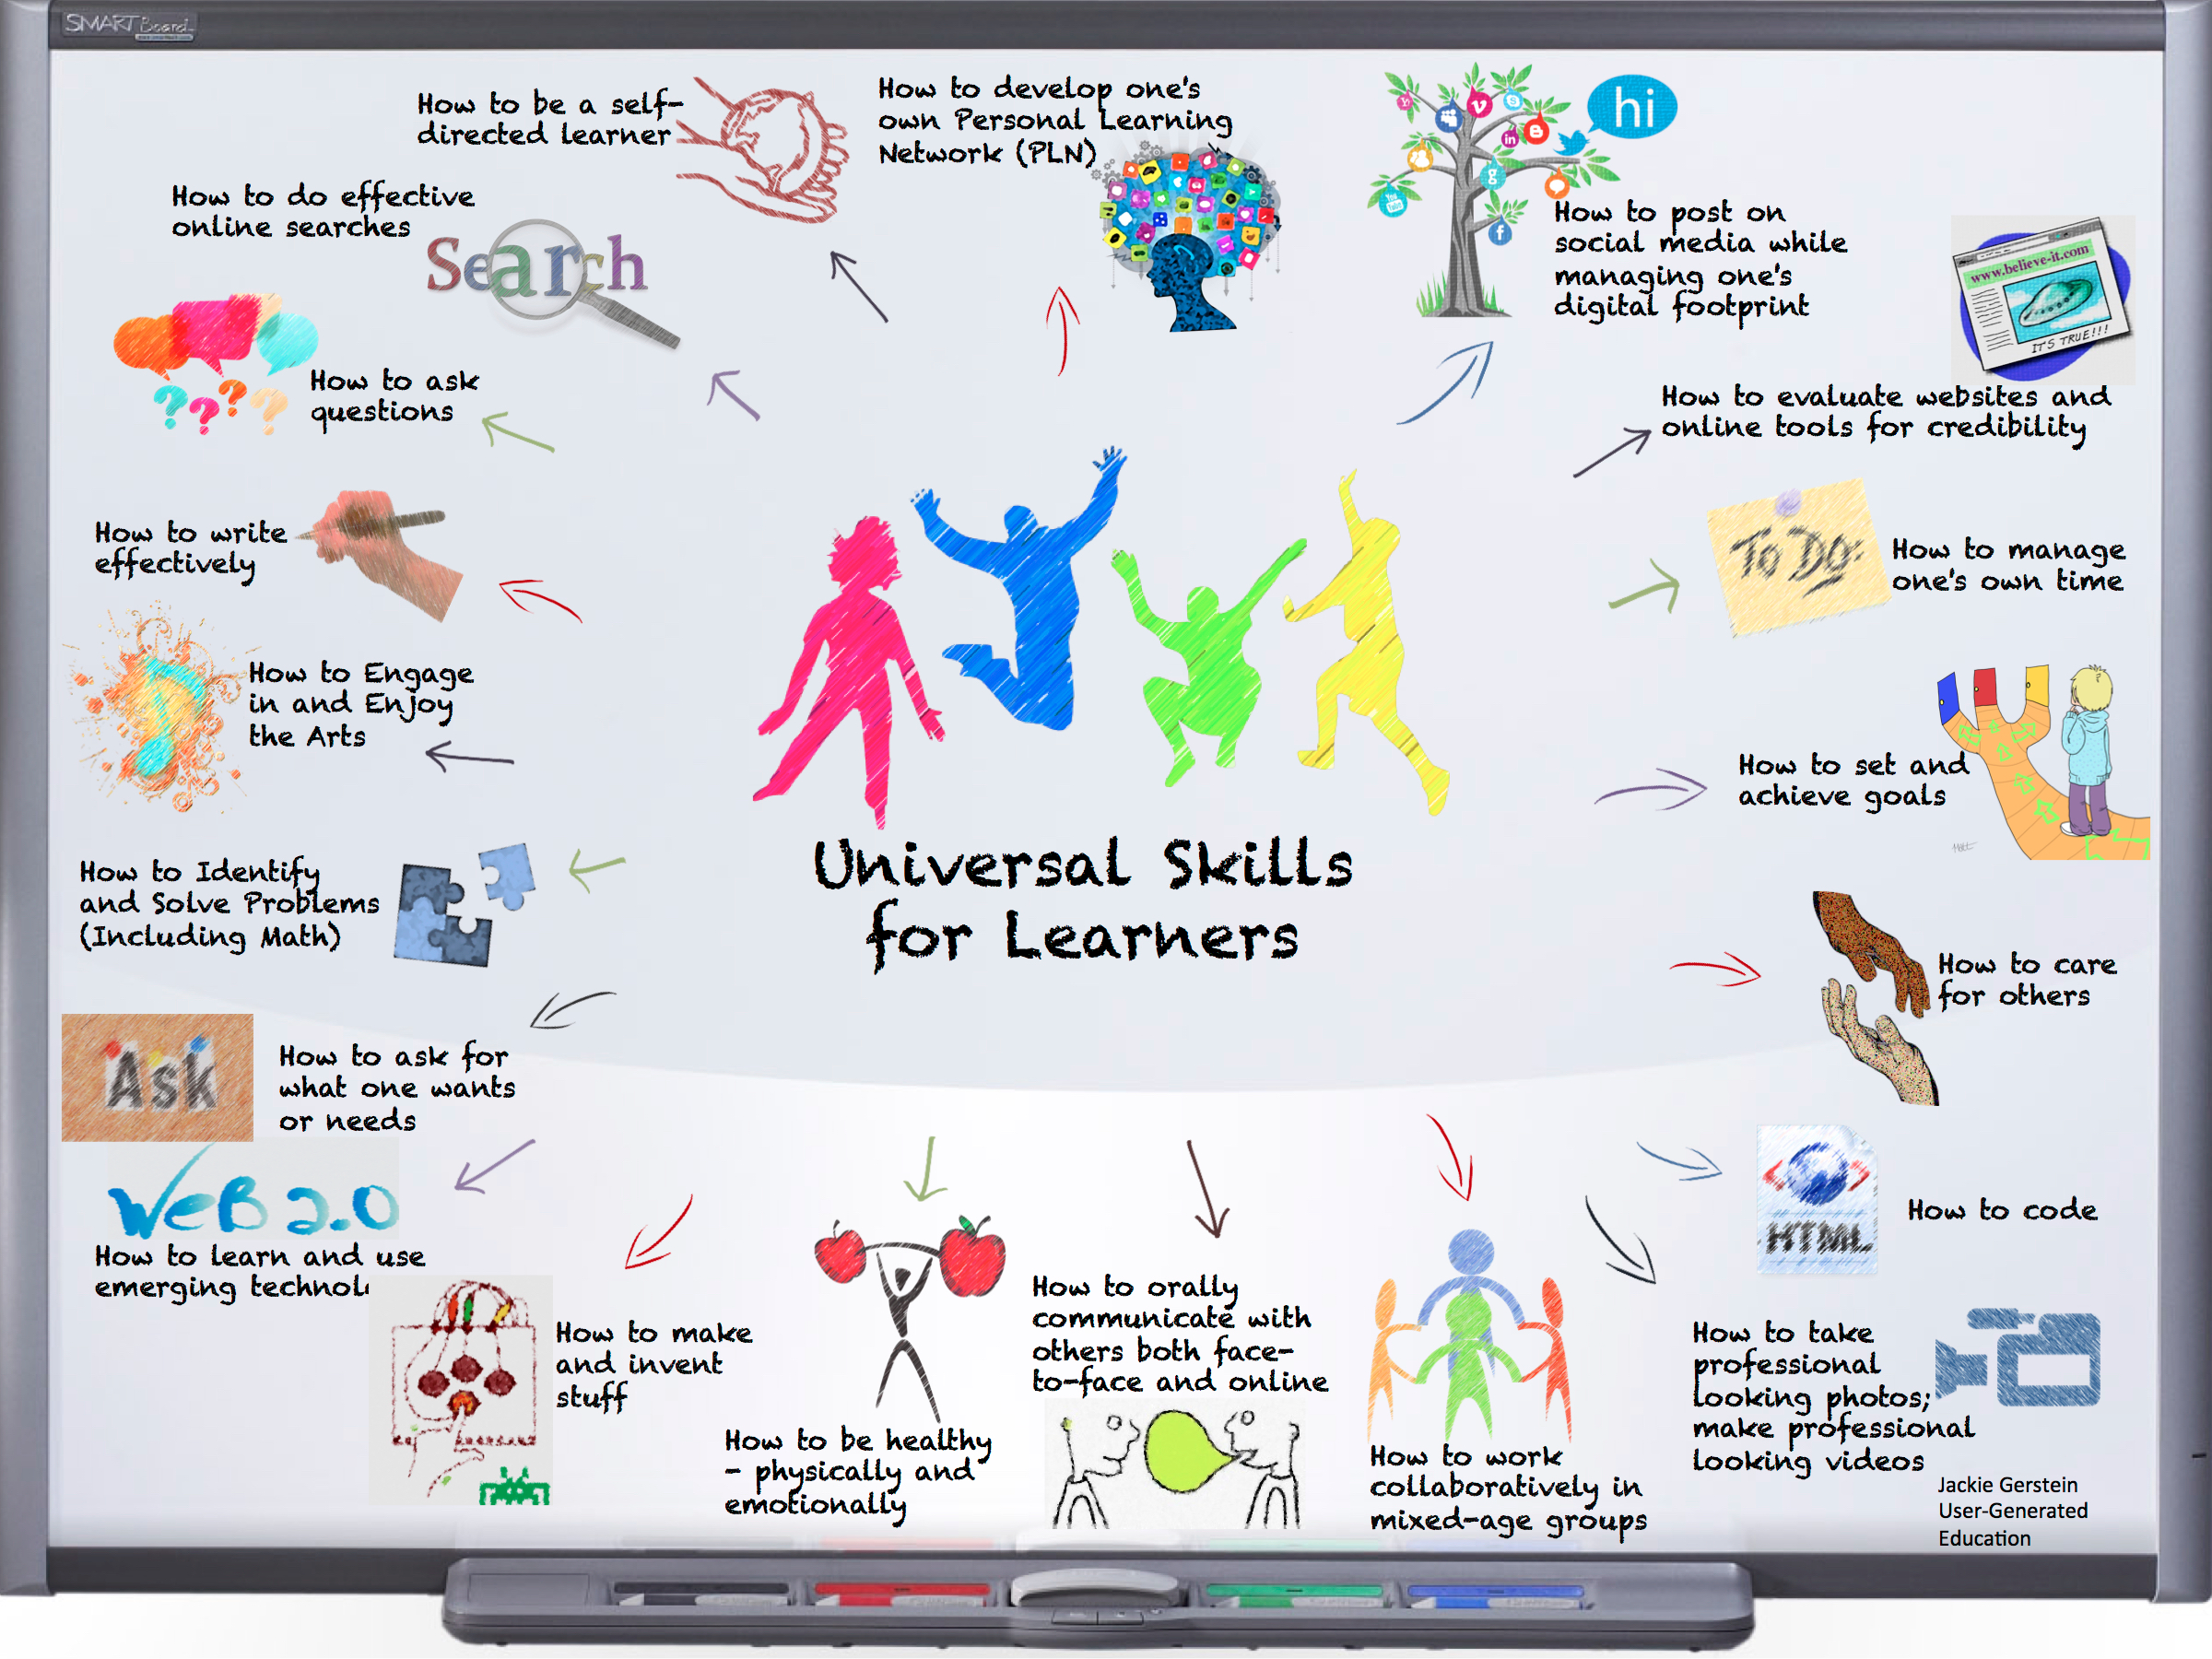
All the Teachers of Team Kereru welcome you to 2016. You are now leaders of the school and as students in Team Kereru you are role models. From the first day let’s work together to make this a great year. A year where we support each other and help each other to learn and take on new challenges together.

Jane Macqueen Team Leader
0708532470 jmacqueen@rototunaprimary.school.nz

What is tikanga?
Tikanga are the traditional cultural values, customs, meanings and way of doing things from a Maori perspective. This year we will examine the Maori way of doing things and also how this looks in practice in the other cultures in Team kereru. This will influence the way we behave as leaders of our school and also other areas of the curriculum. We will be working collaboratively on a piece of art for our team that incorporates both maori tikanga and also the practices of a multi-cultural team. It would be fabulous to include parent and family/whanau voice in this process also.

Term 1 whanaungatanga
Term 2 Manaakitanga
Term 3 Rangatiratanga
Term 4 Tuakana Teina and Ako

